Experiment No: 05
Experiment Name: Advanced Process Management and System Resource Monitoring in Linux
Theory: In contemporary operating systems, a process serves as the basic unit of execution, representing a program that is actively running. A program itself remains a static, passive collection of instructions residing on disk as an executable file; it only becomes a dynamic process when the operating system loads it into RAM and allocates the necessary runtime resources. These allocated resources encompass a private memory layout divided into code, initialized data, dynamic heap, and runtime stack segments, alongside processor registers, an instruction pointer, and active file handles all of which the kernel monitors through a dedicated Process Control Block (PCB). To ensure stability, enforce security boundaries, and enable concurrent execution, the operating system governs how processes are created, scheduled, and terminated by exposing low-level kernel services known as system calls. These calls are triggered through software interrupts (traps) that cause the processor to switch from restricted user space to elevated kernel space. Rather than consolidating all lifecycle operations into a single comprehensive function, UNIX-based and POSIX-compliant platforms distribute process management responsibilities across three separate, specialized system calls.
Commands and Output:
1. Process Creation and Branching with fork(): The os.fork() system call creates a new process by duplicating the existing calling process. The invoking entity is known as the parent process, while the newly created clone is the child process. Upon invocation, fork() splits the execution flow and returns twice:
- It returns 0 inside the child process to identify the child context.
- It returns the unique non-zero Process Identifier (PID) of the newly created child inside the parent process for process tracking and control.
- It returns a negative value (< 0) if process creation fails.
Using os.getpid(), each process can identify its own unique PID assigned by the operating system kernel.
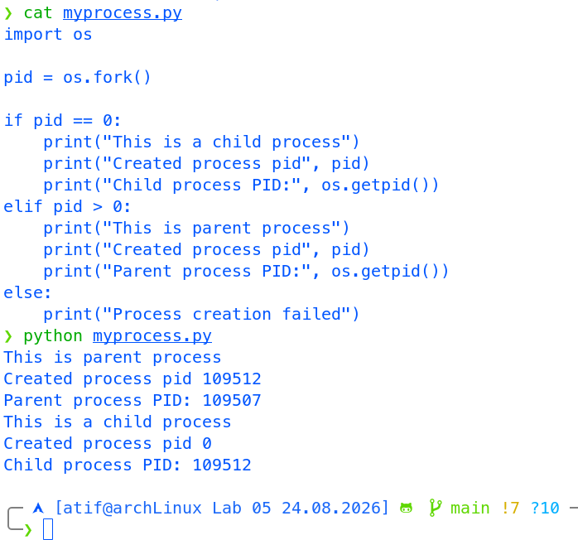

2. Program Execution via execl() and Process Synchronization with waitpid():
- Address Space Replacement (os.execl()): The exec family of system calls (such as execl()) replaces the current process memory image (code, data, heap, and stack) with a completely new executable binary (e.g., /bin/ls). It does not create a new process; instead, it overlays the existing child’s execution context, so the code following the exec call is destroyed and never reached unless an error occurs.

- Parent-Child Synchronization (os.waitpid()): The waitpid() system call suspends parent execution until a specified child process terminates. This mechanism ensures proper lifecycle management, collects the child's termination status, and frees its Process Control Block (PCB) entry, preventing the child from persisting indefinitely as a zombie process.

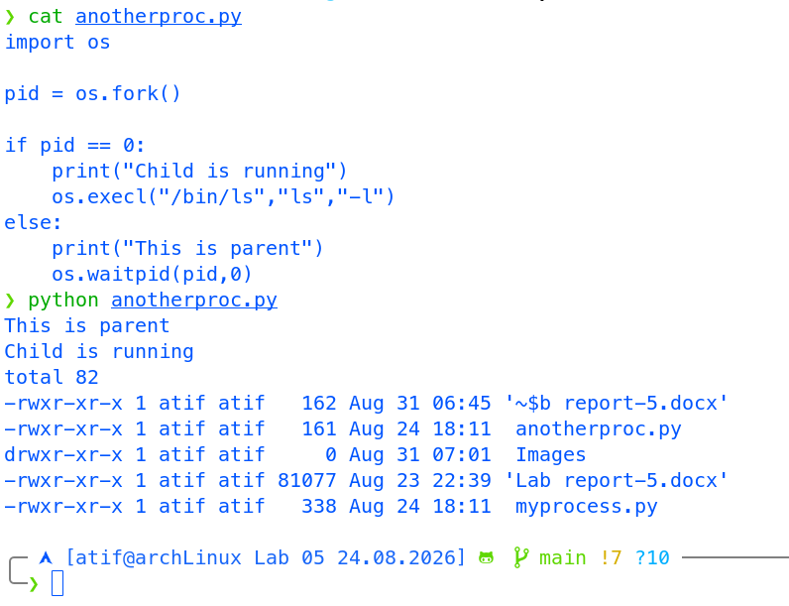

Discussion:
This experiment demonstrated the practical implementation of low-level process control mechanisms in Linux using Python's os module. Through the first script, we observed how the os.fork() system call creates a concurrent child process by cloning the parent's address space. By evaluating the return value of os.fork(), the program established distinct execution branches, where the child received 0 and the parent received the newly created process's non-zero PID. Tracking process identifiers via os.getpid() verified that the operating system assigned unique integer identifiers to each independent execution context. In the second script, we analyzed address space replacement and parent-child synchronization. Executing os.execl() within the child process replaced its memory image with the binary instructions of the /bin/ls utility, causing the newly loaded program to execute within the child's context without returning. Meanwhile, the parent process invoked os.waitpid(), transitioning to a waiting state until the specified child completed its execution. This synchronization ensured orderly sequential execution and demonstrated how parent processes manage child lifecycles, collect termination statuses, and prevent the accumulation of zombie processes in the system.

